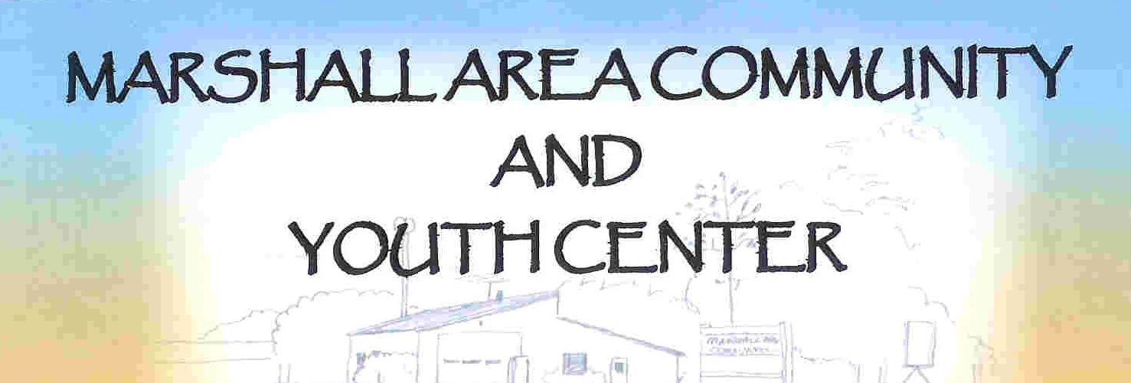

Marshall Lions Club &
Marshall Youth Center
Christmas After School

Cookies, Hot Chocolate, Christmas Card Making & Christmas Bingo

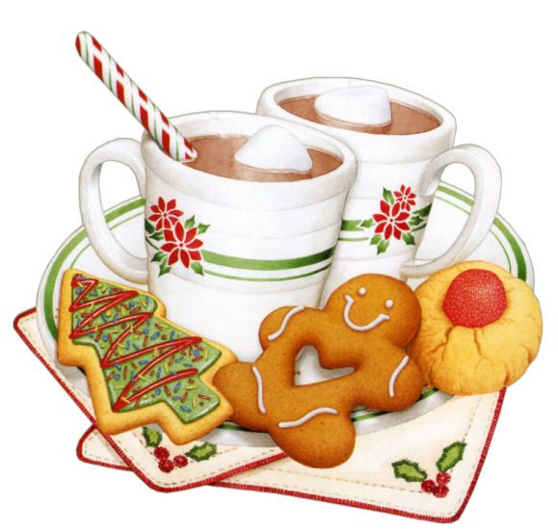
Thursday, December 17th
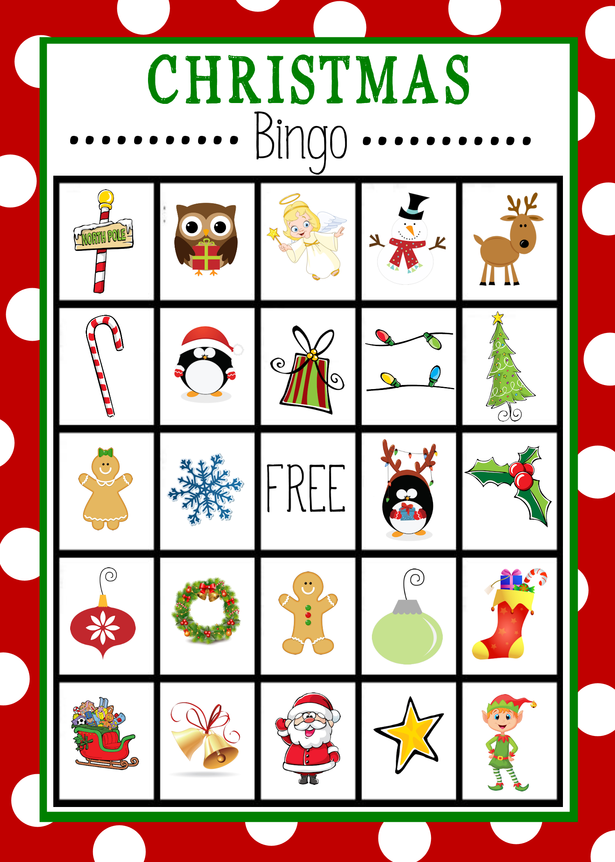
3:30 – 5:30

All children are welcome. Parents or guardians must accompany any child age 5 and under.

